**Project 5- Making LCD Thermometer with Arduino and LM35**

**The materials and supplies we need:**

1. Temperature Sensor (LM35)
2. 16×2 LCD I2c

3)Jumper wires (generic)

4)Arduino UNO

5)Breadboard(generic)

1. **What is** **Temperature Sensor (LM35)?**

LM35 is a temperature sensor that outputs an analog signal which is proportional to the instantaneous temperature. The output voltage can easily be interpreted to obtain a temperature reading in Celsius.

* What Does an LM35 work?
  + It has an output voltage that is proportional to the Celsius temperature.
  + The scale factor is .01V/oC or 10 mV/oC
  + The LM35 maintains an accuracy of  +/-0.4 oC at room temperature and +/- 0.8 oC over a range of 0 oC to +100 oC.
  + Another important characteristic of the LM35DZ is that it draws only 60 micro amps from its supply and possesses a low self-heating capability. The sensor self-heating causes less than 0.1 oC temperature rise in still air.

1. **What is 16×2 LCD I2c?**

This is a 16x2 LCD display screen with I2C interface. It is able to display 16x2 characters on 2 lines, white characters on blue background.

Usually, Arduino LCD display projects will run out of pin resources easily, especially with Arduino Uno. And it is also very complicated with the wire soldering and connection. This I2C 16x2 Arduino LCD Screen is using an I2C communication interface. It means it only needs 4 pins for the LCD display: VCC, GND, SDA, SCL. It will save at least 4 digital/analog pins on Arduino. All connectors are standard XH2.54 (Breadboard type). You can connect with the jumper wire directly.

**Circuit Diagram:**

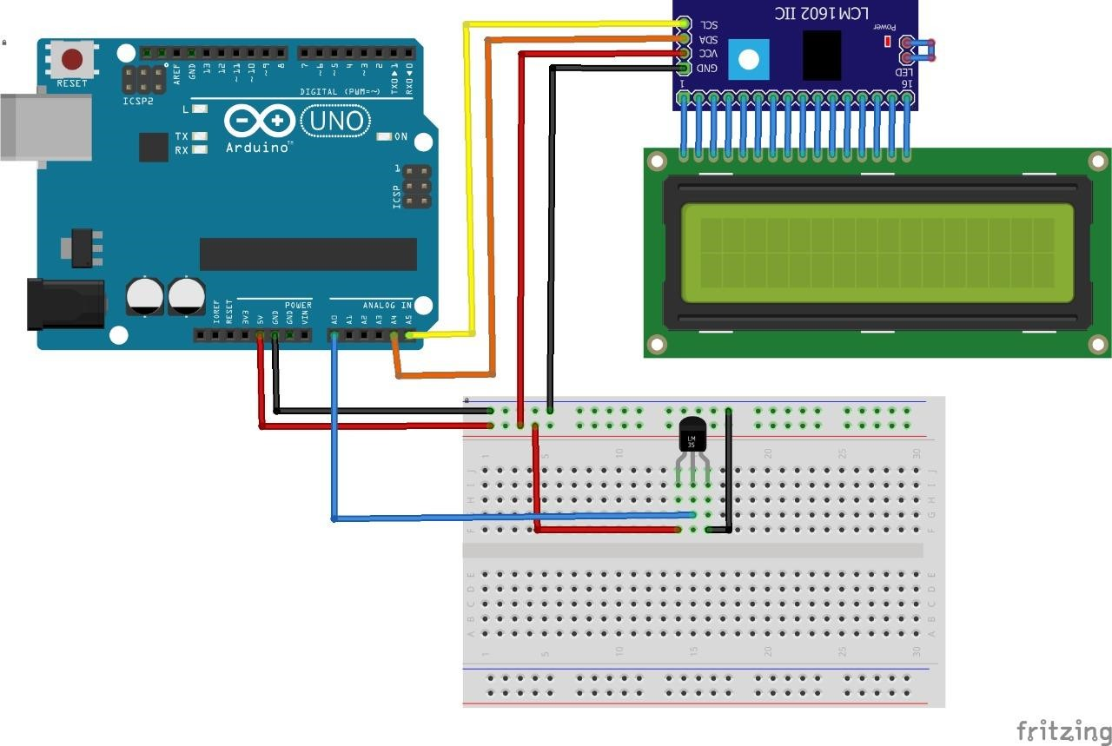

**For This Code Scan the QR Code**